# Project Design Phase-I Solution Architecture

**Crime Vision: Advanced Crime Classification with Deep Learning**

Project Name

**Solution Architecture:**

The solution architecture for advanced crime classification with deep learning typically involves several components working together. Here's a high-level overview of a possible architecture:

# DATA COLLECTION AND STORAGE:

Crime Scene Data: Various types of crime scene data, including images, audio recordings, and text documents, are collected from different sources such as surveillance cameras, emergency calls, witness statements, or police reports.

Data Storage: The collected data is stored in a scalable and secure storage system, which can be a distributed file system, object storage, or a database designed to handle large volumes of multimodal data.

# PREPROCESSING AND FEATURE EXTRACTION:

Data Preprocessing: The collected data undergoes preprocessing steps to normalize, clean, and transform it into a suitable format for deep learning algorithms. This may involve tasks like resizing images, audio signal processing, text cleaning, tokenization, and feature extraction.

Feature Extraction: Deep learning models typically require high-level features for effective crime classification. Techniques like convolutional neural networks (CNNs) for images, recurrent neural networks (RNNs) or transformers for text, and spectrogram analysis for audio can be used to extract meaningful features from the preprocessed data

.

# DEEP LEARNING MODEL:

Model Architecture: A deep learning model architecture is designed to incorporate multiple modalities and process the extracted features. This can involve combining convolutional layers, recurrent layers, or attention mechanisms, depending on the nature of the data and the problem at hand.

Training: The model is trained on a labeled dataset, where each sample includes the multimodal data and the corresponding crime classification label. Training involves optimizing the model's parameters using techniques like backpropagation and gradient descent.

Validation and Hyperparameter Tuning: The model's performance is evaluated on a separate validation dataset to assess its accuracy and generalization. Hyperparameter tuning techniques like grid search or Bayesian optimization can be employed to optimize the model's performance

# 4 MODEL DEPLOYMENT AND INFERENCE:

Model Deployment: The trained deep learning model is deployed into a production environment, which can be on-premises or in the cloud. The deployment can be achieved through containerization using technologies like Docker or by creating an API for serving predictions.

Real-Time Inference: Law enforcement agencies or investigators can submit new crime scene data to the deployed model for real-time inference. The model processes the input data and provides crime classification predictions, indicating the type of crime associated with the given scene

.

# MONITORING AND FEEDBACK LOOP:

Model Performance Monitoring: The deployed system continuously monitors the performance and behavior of the deep learning model. This includes tracking metrics such as accuracy, precision, recall, and latency to ensure the model is functioning optimally.

Feedback Loop and Model Updates: Feedback from users, domain experts, or law enforcement agencies is collected to refine and improve the model. New data can be periodically incorporated to retrain the model, ensuring it adapts to evolving crime patterns and maintains high accuracy levels.

# INTEGRATION AND USER INTERFACE:

Integration with Law Enforcement Systems: The advanced crime classification system can be integrated with existing law enforcement systems, such as case management systems or crime databases, to facilitate seamless data exchange and workflow integration.

User Interface: A user interface is developed to allow investigators to interact with the system. The interface can enable data submission, display classification results, provide visualizations, and support user feedback.

# SECURITY AND PRIVACY:

Data Security: Security measures, including encryption, access controls, and secure communication protocols, are implemented to protect sensitive crime scene data from unauthorized access or breaches.

Privacy Protection: The system adheres to privacy regulations and best practices, ensuring that personal information and confidential data are handled with care and privacy-preserving techniques are applied where necessary.

# Example - Solution Architecture Diagram:

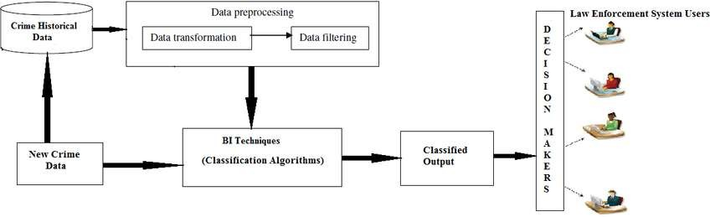

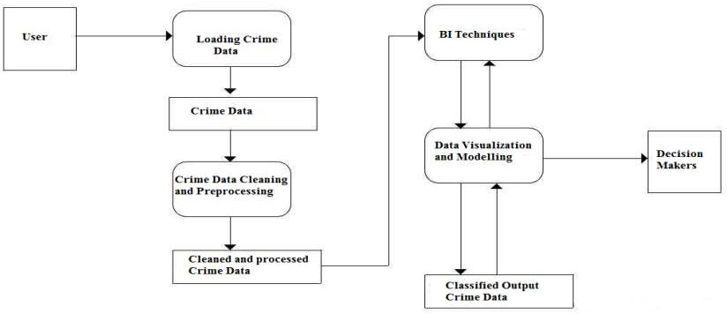

*Figure 1: Architecture and data flow of the Advanced crime classification with deep learning*